June 11th, 2023

Prelude by Joyce Noyce

Call to Worship

Announcements

Offertory

Prayer

Praise and Worship

Ministry of the Word
Tony Borton

Closing Song

Church nursery is provided for children through age 3
Today: Eden West & Sarah Watson
Next Week: Brooke & Halle Mickelsen

CALENDAR

Today 9:30 a.m. Sunday School
10:45 a.m. Morning Worship
1:30-3:00p.m. High School Youth Group
4:00 p.m. Thompson Small Group

Mon. June 12th 7:00 p.m. Watson Small Group

Tues. June 13th 6:30 a.m. Men’s Bible Study
Wed. June14th 6:00-8:00 p.m. Youth Group

Thurs. June 15th 6:30 p.m. Deacon/Elder Meeting
7:00 p.m. Church Board Meeting

Sat. June 10th 7:00 a.m Men’s Prayer Breakfast/Tasty Treats

ANNOUNCEMENTS

We would like to give huge thank you to everyone who participated in VBS this year! Our church could not do it without so many people contributing!!

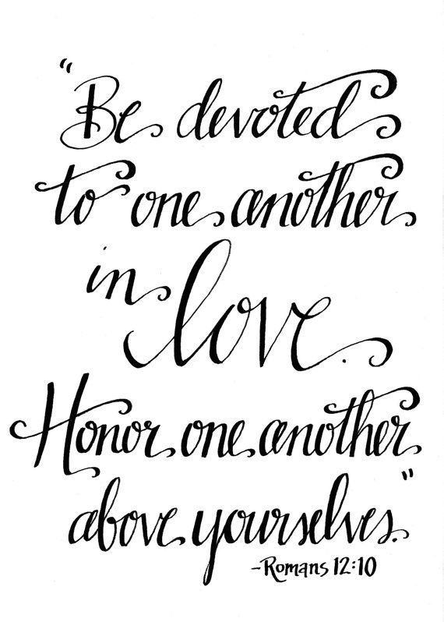

If you are new or visiting, we ask that you fill out a Welcome Card
from the table in the foyer and put it in the offering plate or give
it to a pastor. Thank you for joining us this morning!

CHURCH OFFICERS
Pastor: Tony Borton (307-631-7544)
Youth Pastor: Danny Fredericks (331-5819)
Visitation Minister: Peter Thompson (331-5400)
Elders: Deacons:
Peter Thompson (331-5400) John Dennis (331-9380)
Paul Robertson (331-3772) Kent Brickman (331-9975)
John Watson (307-836-2647) Martin Hicks (331-0660)
Tom Watson (307-532-0322) Zack Rose (331-8743)
Bruce Hilty (331-2341)
Moderator: Kerry Volz Financial Secretary: Diane Robertson
Treasurer: Carolyn Morford Clerk: Judy Miller
S.S. Superintendent: Roy Birt

June Birthdays & Anniversaries

10 Alan & Bonnie Weber
11 Iselle West
12 Wyatt & Melanie Dunlap
14 Brock Weber
15 Jill Weaver
18 Karen Kelley
19 John & Kathy Watson
20 Ferol Hitt
Anthony Eugene Borton
Sawyer Witt
Maddox Witt
22 Martin & Tanda Hicks
Junie Stevens
24 Kerry & Gayle Volz
Mike & Karen Kelley (45 years)
Levi Mickelsen
26 Kerry Volz
28 Andi Bush
30 Bonnie Weber

Wheatland Bible Church exists to equip the saints for the work of ministry and to build up the body of Christ.
Ephesians 4:12

Acts 4:11 NKJV

This is the ‘stone which was rejected by you builders,

which has become the chief cornerstone.’

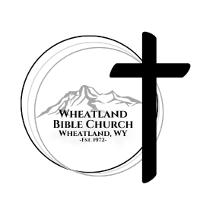

Wheatland Bible Church
Highway 312 & Palmer Canyon Rd.
Wheatland, WY 82201
307-322-9869
www.wheatlandbible.com
Tony Borton, Pastor
Danny Fredericks, Youth Pastor
Peter Thompson, Visitation Minister

